Bienvenid@s al nuevo año 2021!!!! Esperamos se encuentren bien, que hayan descansado y disfrutado las vacaciones después de un 2020 tan complejo. Ahora nos toca poner manos a la obra para retomar y terminar lo que nos quedó pendiente.

Desde nuestra área de inglés les hacemos llegar un cálido abrazo y esperamos que estén entusiasmad@s de comenzar!!!!

Después de hacer el T.P lo mandas a:

[ingles.cpem49@gmail.com](mailto:ingles.cpem49@gmail.com) o,

[carlafilippuzzi@gmail.com](mailto:carlafilippuzzi@gmail.com)

iglesiassilvinad@gmail.com

**THE KING OF ROCK AND ROLL**

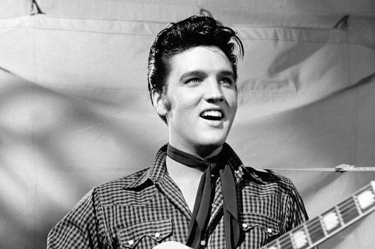The boys *cut* their hair like his and dressed like him. He was an American revolution and teenagers all over the United States went wild.

Elvis Aaron Presley was born in a poor family on January 8, 1935in Mississippi. When he was 13, his family *moved* to Memphis, Tennessee.

Elvis loved music, and the same year, his mother bought him a guitar. He learned to play it well, and in 1954 he went to a recording studio to make a record for his mother’s birthday. Sam Phillips, the manager of the studio, was *impressed* when he heard Elvis’s voice. Elvis was white, but he *sang* like a black man. Sam produced Elvis’s first record called “That’s all right, Mama”.

In 1955, Elvis appeared on TV on the famous Ed Sullivan Show. The following year he went to Hollywood and made his first movie called “love me *tender*”. In 1958, he *joined* the army and went to Germany. When he came back to the United States in the early sixties, pop music wasn’t the same. Groups like The Beach Boys and The Rolling Stones were very popular.

Elvis couldn’t take it. He became fat and depressed. He was rich, but very lonely. On August 16, 1977, he died of a *heart attack* in his *mansion*, in Memphis, Tennessee.

His house is a museum today, and every year, thousands of fans come to see it. People all over the world continue to buy his records, and in the United States, *imitators* dress up like Elvis Presley, *shake* their hips, and pretend to be the King of Rock and Roll.

**ACTIVIDADES:**

1.a) Leer el texto e identificar ¿Cual es el Tiempo Verbal que predomina? Dar razones a tu respuesta.

1.b) Marcar con azul las palabras transparentes que aparezcan en el texto.

2) Leer el texto por segunda vez y escribir los verbos en la columna que corresponda.

|  |  |
| --- | --- |
| **VERBO REGULAR** | **VERBO IRREGULAR** |
|  |  |
|  |  |
|  |  |
|  |  |
|  |  |
|  |  |
|  |  |

3) Completar la línea de tiempo, en base al texto sobre Elvis Presley.

**1935 1954 1955 1958 1977 today**

**Elvis Presley was born**

4)EXTRAER DEL TEXTO E INTERPRETAR UNA ORACIÓN CON VERBO REGULAR EN PASADO POSITIVA; UNA ORACIÓN CON VERBO IRREGULAR EN PASADO POSITIVA, UNA ORACIÓN EN PASADO NEGATIVA, 4(CUATRO) ADJETIVOS, 4(CUATRO) SUSTANTIVOS.

5.a) COMPLETAR CON PALABRAS DEL TEXTO LAS SIGUIENTES DEFINICIONES

a. Indigent:______________

b. Rich man: _____________

c. Cardiovascular Disease: ___________

d. Influence: ____________

5.b) Re lee el texto y resumí con tus palabras el mismo, comentá que eventos positivos en la vida de Elvis Presley se mencionan.