***1er Año C.P.E.M 49***

Bienvenid@s al nuevo año 2021!!!! Esperamos se encuentren bien, que hayan descansado y disfrutado las vacaciones después de un 2020 tan complejo. Ahora nos toca poner manos a la obra para retomar y terminar lo que nos quedó pendiente.

Desde nuestra área de inglés les hacemos llegar un cálido abrazo y esperamos que estén entusiasmad@s de comenzar!!!!

Después de hacer el T.P lo mandas a:

[ingles.cpem49@gmail.com](mailto:ingles.cpem49@gmail.com) o,

1° E: martelmariafernanda@gmail.com

1°D: [carlafilippuzzi@gmail.com](mailto:carlafilippuzzi@gmail.com)

1°A: nadia.sepulveda88@gmail.com

1°B/C: iglesiassilvinad@gmail.com

***Trabajo practico integrador***

1. **Complete the sentences with a suitable subject**

**pronoun and the correct form of the verb ‘to be’.**

1- Mathew is new at school.______ super cool!

2. Mrs Thompson‘s our new Science teacher._______ really nice.

3. These are the Maths exercises._______very difficult to understand.

4. My dad is a History teacher._______ very strict.

5. Our school is in the city centre._________great!

6. I’m a big fan of Pitbull and Kesha. I think__________-fantastic!

7. Mike and I are in the same school._________very good friends.

8. A: Where’s Del Potro from?

B: ___________from Tandil, Argentina.

**2). Answer these questions.**

1. What is your name? ___________________________________
2. What is your surname? ____________________________________
3. Are you from Buenos Aires? ______________________________________
4. Where are you from? ________________________________________
5. Are you 12 years old? ___________________________________
6. How old are you? __________________________________

3). Write **SIX words** in each category.

|  |  |
| --- | --- |
| ***COLOURS*** | ***SCHOOL OBJECTS*** |
|  |  |

4). Complete using **THIS, THAT, THESE** or **THOSE.**

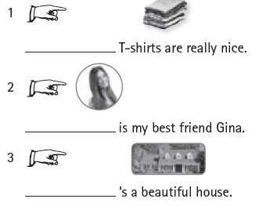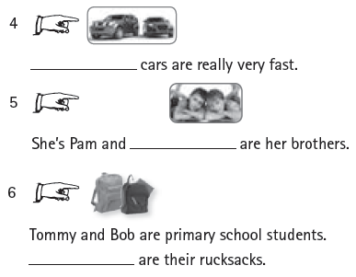

**5) Write about you. (name, age, favourite colour)**

_______________________________________________________

_______________________________________________________

_______________________________________________________

_______________________________________________________