**T.P INTEGRADOR 3° AÑO**

Bienvenid@s al nuevo año 2021!!!! Esperamos se encuentren bien, que hayan descansado y disfrutado las vacaciones después de un 2020 tan complejo. Ahora nos toca poner manos a la obra para retomar y terminar lo que nos quedó pendiente.

Desde nuestra área de inglés les hacemos llegar un cálido abrazo y esperamos que estén entusiasmad@s de comenzar!!!!

Después de hacer el T.P lo mandas a:

[ingles.cpem49@gmail.com](mailto:ingles.cpem49@gmail.com) o,

3°B Laura Verdugo: lauravnqn@yahoo.com.ar

3°C Fernanda Martel: [martelmariafernanda@gmail.com](mailto:martelmariafernanda@gmail.com)

3°A [carlafilippuzzi@gmail.com](mailto:carlafilippuzzi@gmail.com)

El resto de los 3eros enviar mail a: iglesiassilvinad@gmail.com

**SIMPLE PRESENT**

1. Read the text and answer the questions. (Lee el texto y contesta las preguntas).

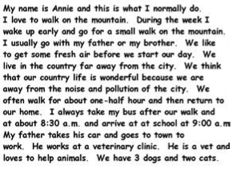

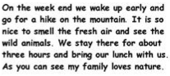

1. What does Annie love to do? _________________________________________________________________
2. Who does she walk with? ____________________________________________________________________
3. Where does she live? _______________________________________________________________________
4. How long does she walk? ____________________________________________________________________
5. What time does she arrive at school? __________________________________________________________
6. Why does her father go to the town? __________________________________________________________
7. What do they do on the weekends? ___________________________________________________________
8. True or false? Justify the false answers. (¿Verdadero o falso? Justificá las respuestas falsas).
9. Annie is a vet. _____ ____________________________________________________________________
10. Annie doesn´t like the mountain. ____ ______________________________________________________
11. Annie lives in the city. ____ _______________________________________________________________
12. Her father is a farmer. ____ _______________________________________________________________
13. They never walk on the mountain. ____ _____________________________________________________
14. Fill in the gaps using the verbs in brackets. Don´t forget the “S”, if necessary. (Completa los espacios usando los verbos entre paréntesis. No te olvides las “S”, de ser necesaria).

Annie ______________ (like) to walk on the mountain. During the week she ______________ (wake up) early and ______________ (go) for a small walk. She usually ______________ (go) with her father and brother.

She ______________ (like) to get some fresh air. She ______________ (not live) in the city.

She always ______________ (take) the bus and _______________ (arrive) at school at 9:00 a.m.

Her father ______________ (take) his car and ______________ (go) to town to work. He ______________ (love) animals. He ______________ (not work) at a clinic, he ______________ (work) in a vet.

They ______________ (like) to go to the mountain on the weekend and ______________ (see) the animals.

Annie´s family ______________ (love) nature.

**PAST SIMPLE**

Frida Kahlo: her biography.

1. Read the biography and complete the text with the Past Simple of the verbs in brackets. (Lee la biografía y completa el texto con el tiempo pasado de los verbos entre paréntesis).

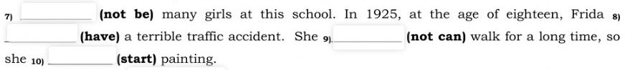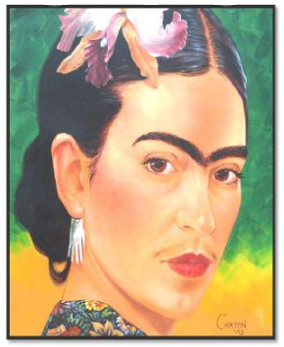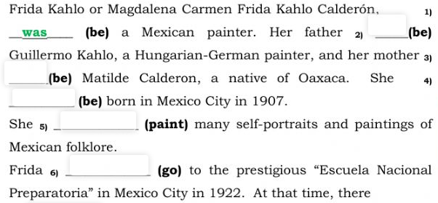

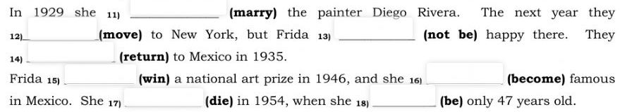

1. Answer the questions. (Responde las preguntas).
2. When was Frida Kahlo born? ________________________________________________________________
3. Where did she go to school? ________________________________________________________________
4. What happened to Frida in 1925? ____________________________________________________________
5. What made Frida start painting? _____________________________________________________________
6. Did Frida enjoy her time in New York? _________________________________________________________
7. When did she win a national prize? ___________________________________________________________
8. Who was her husband? _____________________________________________________________________
9. Using the notes write Anne Frank´s biography. (Usando las notas escribe la biografía de Anna Frank).

1929: 12th June. In Frankfurt, Germany. Jewish girl (Anne) born.

1933: Anne and family moved to Amsterdam.

1940: German government started to persecute Jews.

1942: 12th June Anne received a book for her 13th birthday.

1942: July. Anne´s family move to a room in Anne´s father work to hide themselves from the Germans.

1944: August. Anne´s family was arrested by the Germans.

1944: September: Anne and sister were taken to Auschwitz concentration camp. Months later they died.

After the war: Anne´s father, the only survivor, found Anne´s diary.

1952: The diary - First publication in English.

________________________________________________________________________________________________________________________________________________________________________________________________________________________________________________________________________________________________________________________________________________________________________________________________________________________________________________________________________________________________________________________________________________________________________________________________________________________________________________________________________________________________________________________________________________________